1

create table passenger(

passport_no varchar2(9),

name varchar2(30),

dob date,

email varchar2(15),

booking_id number(4))

alter table passenger add constraint ppk1 primary key(passport_no)

alter table passenger add constraint pfk1 foreign key (booking_id) references booking(booking_id)

alter table passenger modify (name not null)

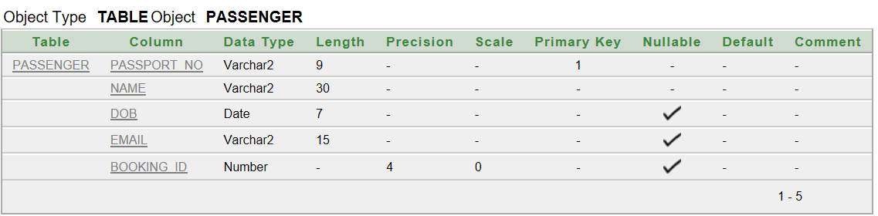

insert into passenger values ('AC234567','Synthia','09-MAY-90','s@yahoo.com',4321)

insert into passenger values ('NG6785431','Huang','01-DEC-99','h@hotmail.com',0987)

insert into passenger values ('DG765432','Naomi','19-JAN-80','n@gmail.com',8973)

insert into passenger values ('ME657890','Wali','23-MAR-88','w@gmail.com', 7865)

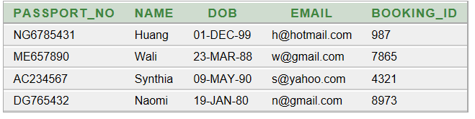

create table nationality(

passport_no varchar2(9),

nationality1 varchar2(15),

nationality2 varchar2(15),

nationality3 varchar2(15))

alter table nationality add constraint pfk7 foreign key (passport_no) references passenger(passport_no)

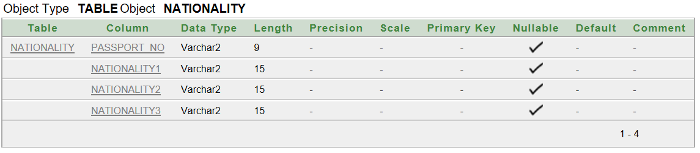

insert into nationality values ('NG6785431','Chinese','American','Australian')

insert into nationality values ('DG765432','Estonian','American','German')

insert into nationality (passport_no,nationality1) values ('AC234567','Bangladeshi')

insert into nationality (passport_no,nationality1,nationality2) values ('ME657890','Portugese','Hungarian')

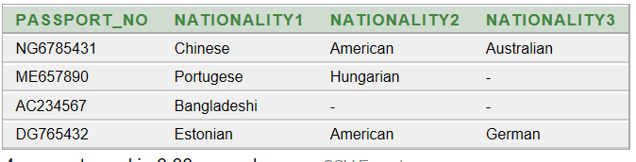

2

create table booking(

booking_id number(4),

seatno varchar2(3),

cp_id number(3),

flight_no varchar2(8))

alter table booking add constraint ppk2 primary key(booking_id)

alter table booking add constraint pfk2 foreign key (flight_no) references flight(flight_no)

alter table booking add constraint pfk3 foreign key (cp_id) references class(cp_id)

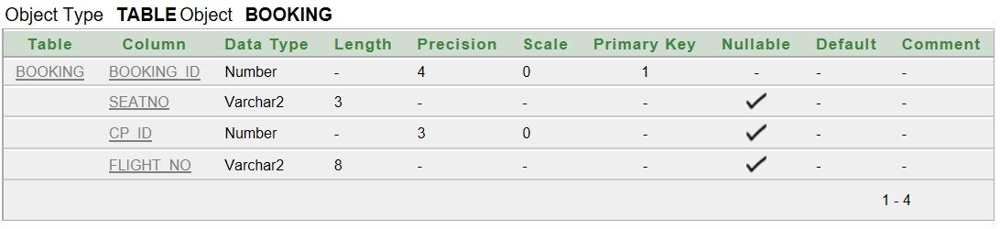

insert into booking (booking_id,seatno) values (0987,'01F',002,'BD13452')

insert into booking (booking_id,seatno) values (7865,'12A',011,'RS13452')

insert into booking (booking_id,seatno) values (4321,'20B',209,'JX563421')

insert into booking (booking_id,seatno) values (8973,'03C',001,'DT789653')

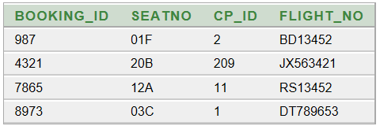

3

create table class(

cp_id number(3),

classname varchar2(10),

price number(4))

alter table class add constraint ppk3 primary key(cp_id)

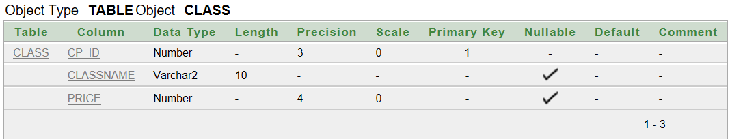

insert into class values(002,'Economy',1000)

insert into class values(011,'Business',1550)

insert into class values(209,'E.Economy',1100)

insert into class values(001,'First',2900)

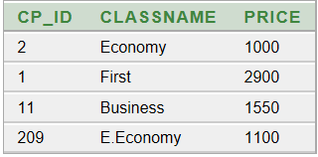

4

create table flight(

flight_no varchar2(8),

departure_time varchar(5),

d_id number(4),

a_id varchar2(4))

alter table flight add constraint ppk4 primary key(flight_no)

alter table flight add constraint pfk4 foreign key (d_id) references journey(d_id)

alter table flight add constraint pfk5 foreign key (a_id) references airplane(a_id)

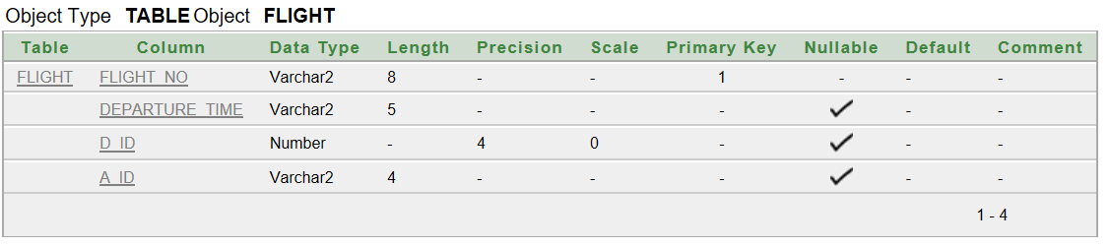

insert into flight values('BD13452','12:30',456,'AD37')

insert into flight values('RS13452','05:00',876,'BN55')

insert into flight values('JX563421','15:50',443,'CG01')

insert into flight values('DT789653','22:05',093,'FT43')

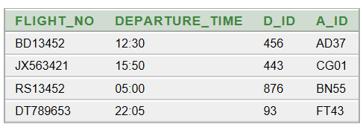

create table stoppage(

flight_no varchar2(8),

layover1 varchar2(3),

layover2 varchar2(3),

destination varchar2(15))

alter table stoppage add constraint pfk8 foreign key (flight_no) references flight(flight_no)

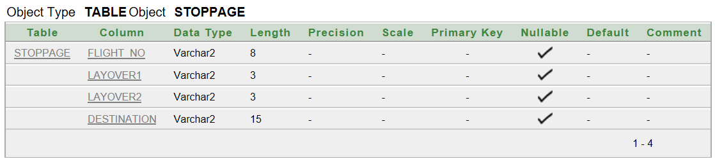

insert into stoppage(flight_no,layover1,destination) values('BD13452','QTR','New York')

insert into stoppage(flight_no,layover1,destination) values('RS13452','HK','Delhi')

insert into stoppage(flight_no,layover1,destination) values('JX563421','CHG','Tokyo')

insert into stoppage values('DT789653','CHG','PNG','Kuala Lampur')

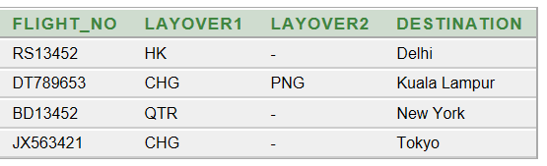

5

create table journey(

d_id number(4),

duration varchar2(5),

route varchar2(15))

alter table journey add constraint ppk5 primary key(d_id)

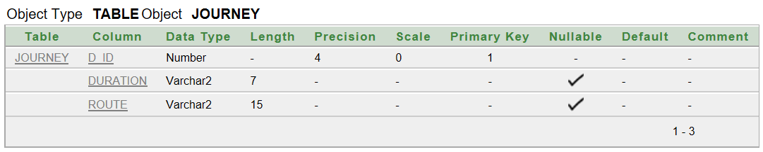

insert into journey values(456,'14H 30M','DAC-QTR-NY')

insert into journey values(876,'14H 30M','RUS-HK-DEL')

insert into journey values(443,'07H 15M','GOA-CHG-TKY')

insert into journey values(093,'05H 40M','CTG-CHG-PNG-KL')

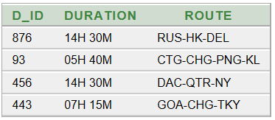

6

create table employee(

e_id number(4),

name varchar2(30),

job varchar2(10),

hiredate date,

salary number(6),

a_id varchar2(4))

alter table employee add constraint ppk6 primary key(e_id)

alter table employee add constraint pfk6 foreign key (a_id) references airplane(a_id)

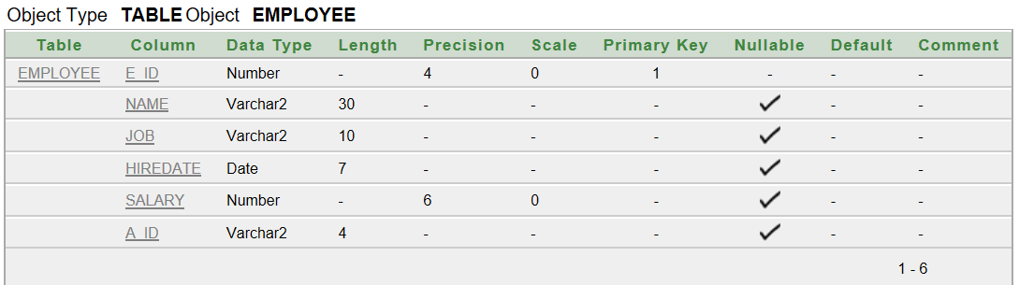

insert into Employee values(4567,'David Miller','Pilot','01-DEC-2017',7500,'BN55')

insert into Employee values(4677,'Maria Wong','Stewardess','21-MAR-2016',5000,'BN55')

insert into Employee values(4321,'Joseph J. Mann','Steward','20-JUN-2018',5000,'AD37')

insert into Employee values(4086,'Noman Yasin','Medic','13-APR-2013',6000,'FT43')

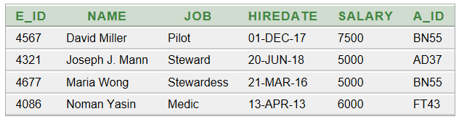

7

create table airplane(

a_id varchar2(4),

type varchar2(10))

alter table airplane add constraint ppk7 primary key(a_id)

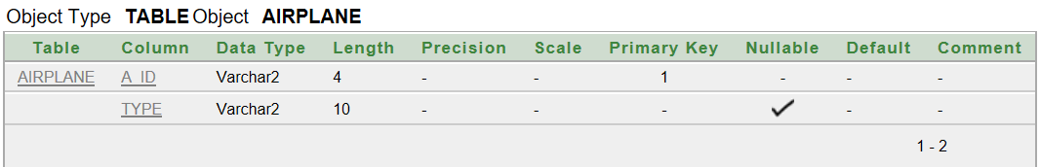

insert into airplane values('AD37','Boeing 777')

insert into airplane values('BN55','Boeing 707')

insert into airplane values('CG01','Airbus 355')

insert into airplane values('FT43','Airbus 701')

